How To Generate A Single Progress Report In Powerschool
- Click on Gradebook
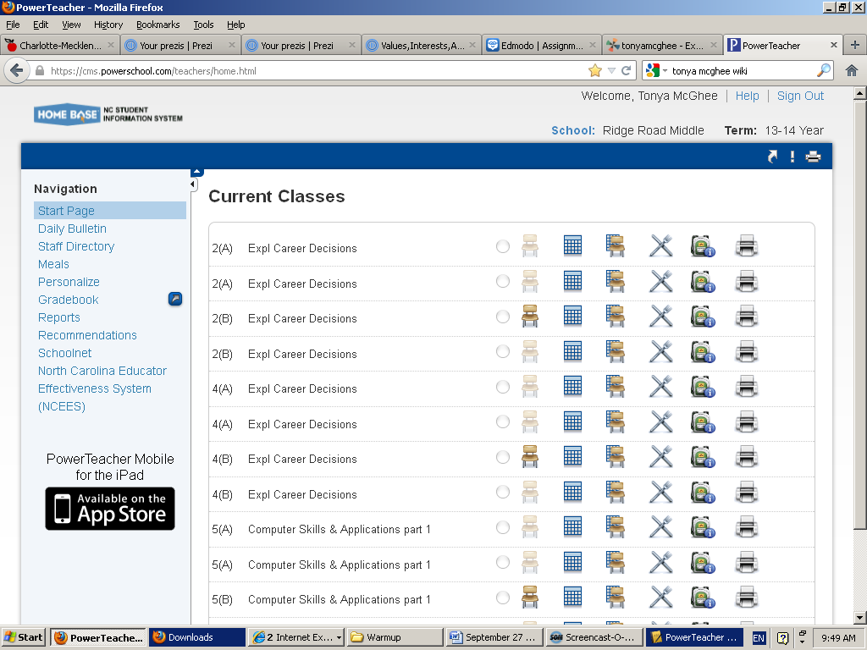

- Select Reports then Individual Report
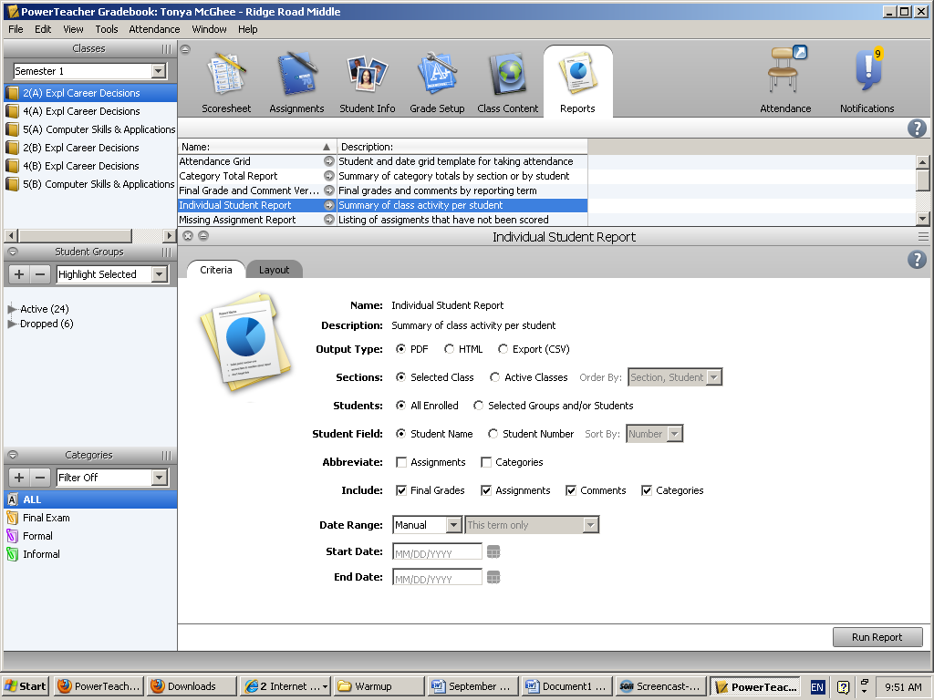

- Double click on Active and select the student. (For multiple students, hold down the control key and select the students). Next, in the middle of the screen next to Students, select the “Selected Groups and/or Students”
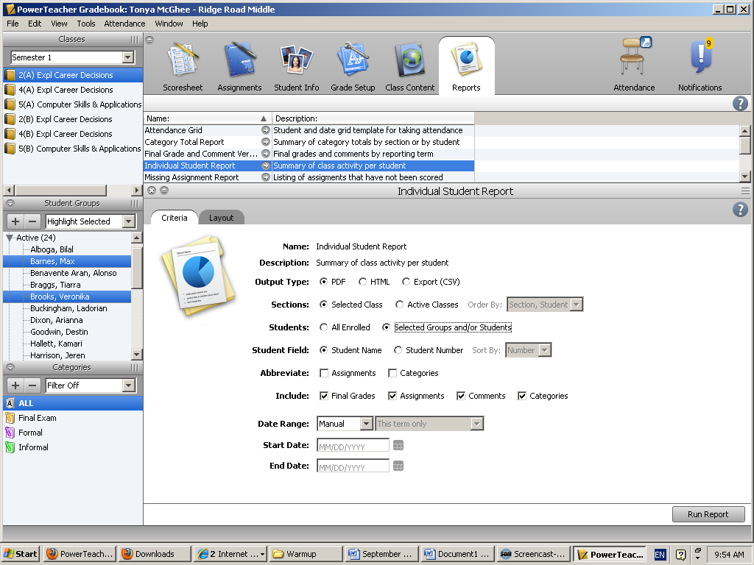

- Now Run Report and Press Ok.

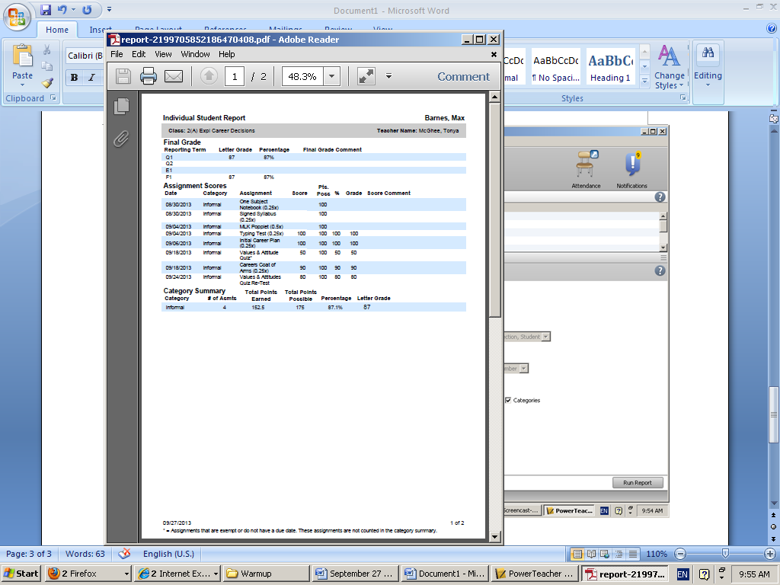
The individual or multiple progress reports has now been generated.

