Powerschool: How To Finalize Grades for Report Cards
- After launching Gradebook, click on Reports
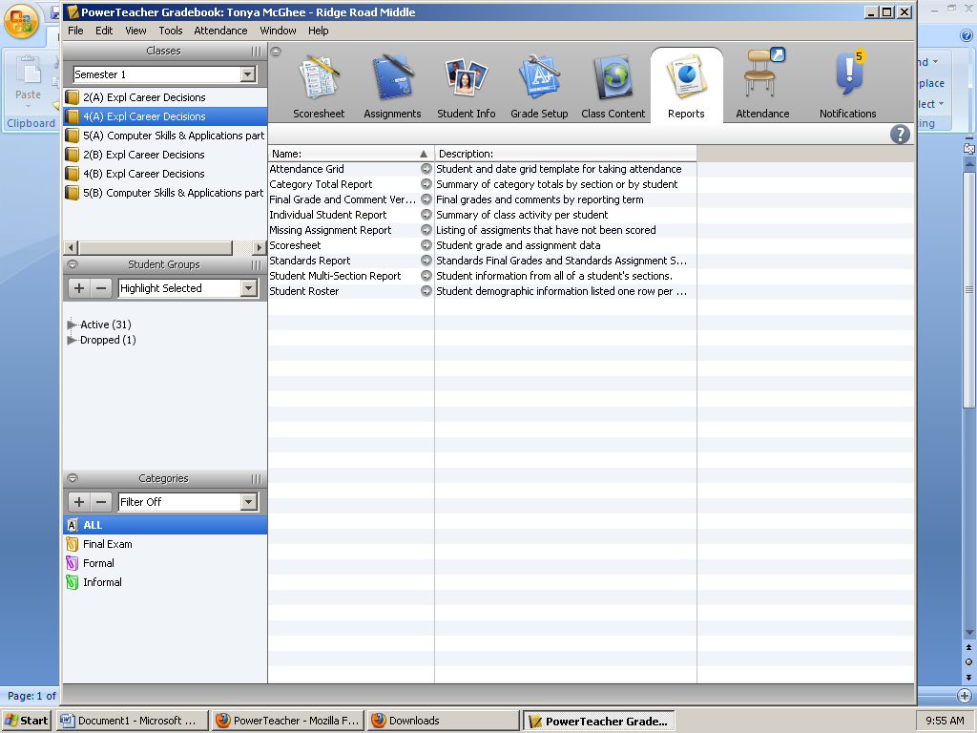

- Double-click on Final Grade and Comment Verification. Leave all the default check marks and change the Reporting Term to Q1. DO NOT CLICK ON RUN REPORT YET. Go to the next step.
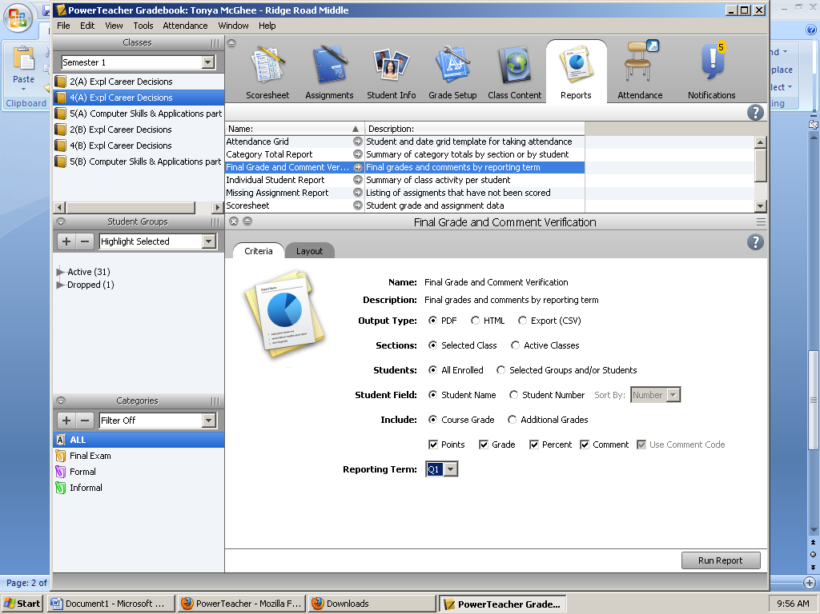

- Now go to Layout Tab on the same screen and check the Signature Line box. The signature line must appear on this report. Next, click Run Report and OK
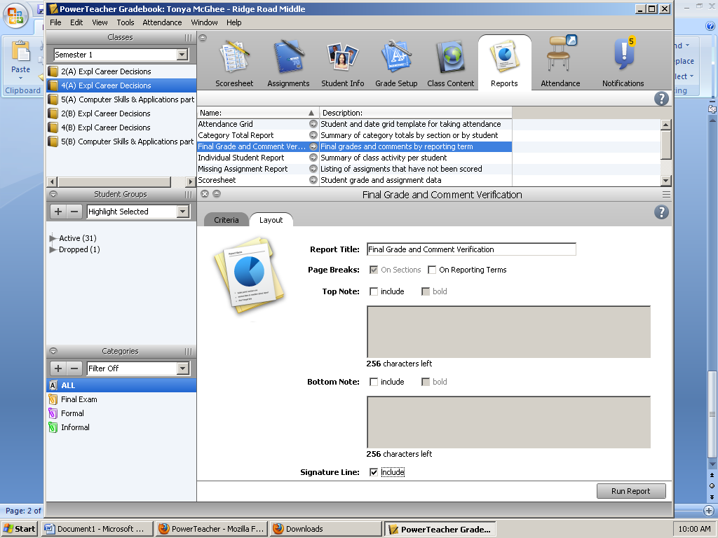

- The report will show the student’s name and final numerical grade. Print, sign, and date.
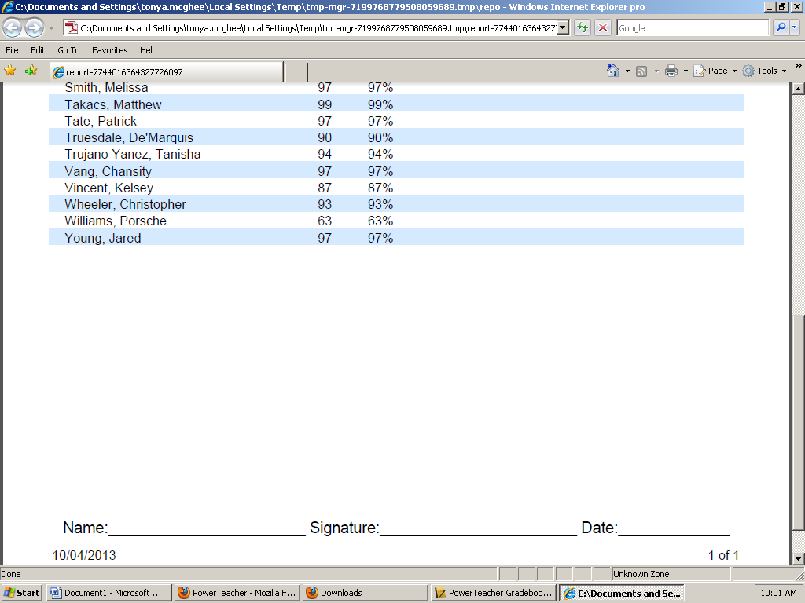

- Now go back to Reports and Double-click on Scoresheet
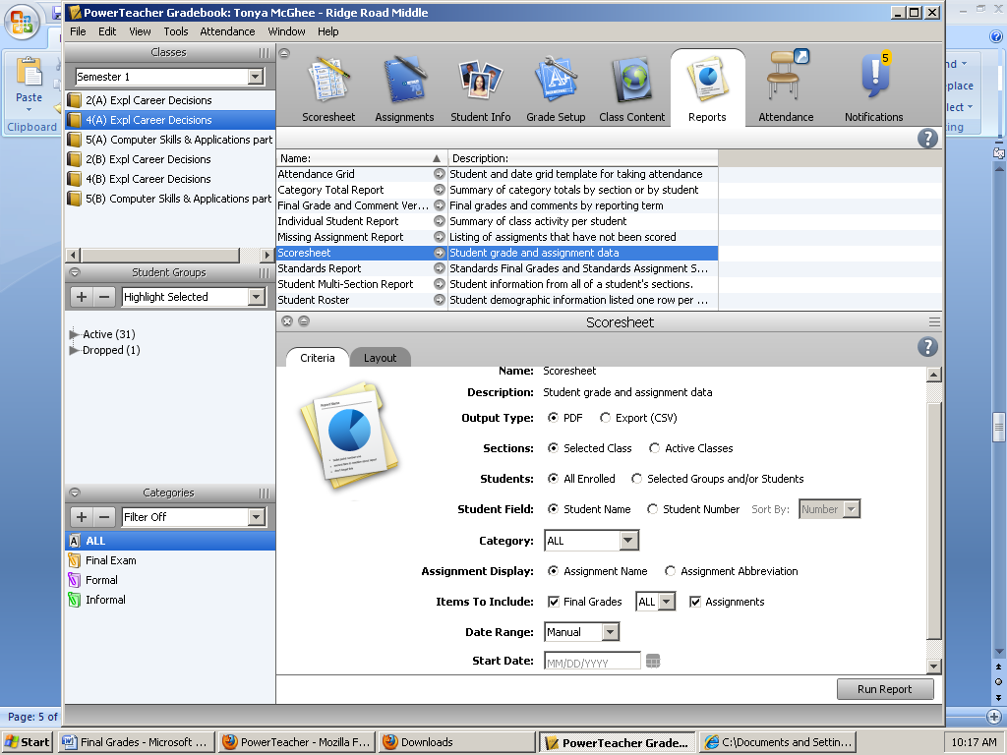

- On the line for Items to Include, change All to Q1. Click Run Report and OK.
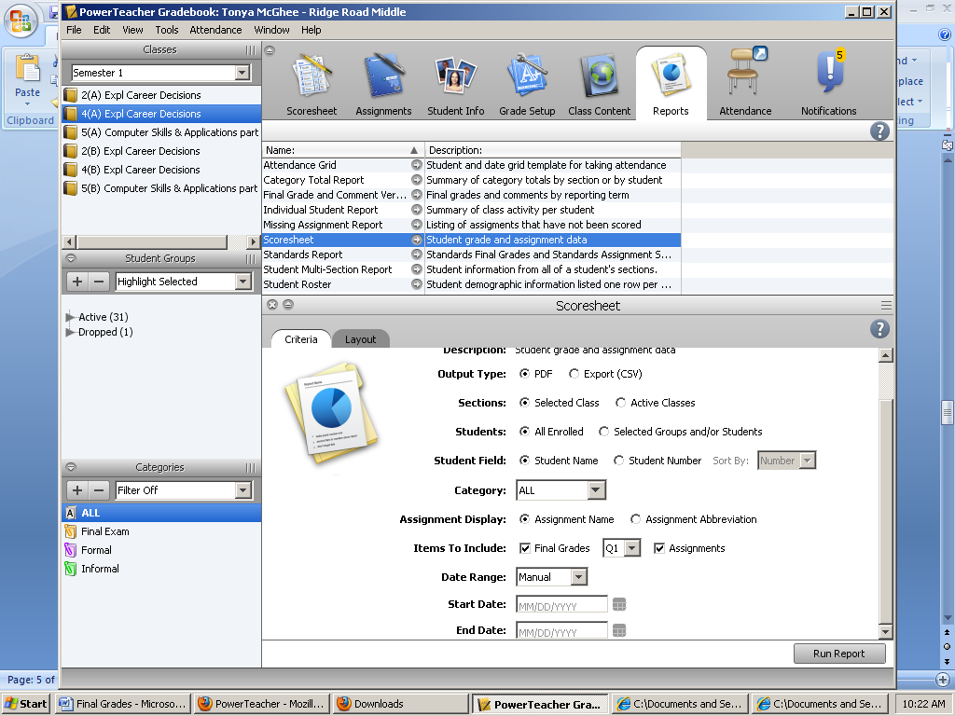

- The entire gradebook for the class will generate. Print and attach to the Final Grade Sheet.
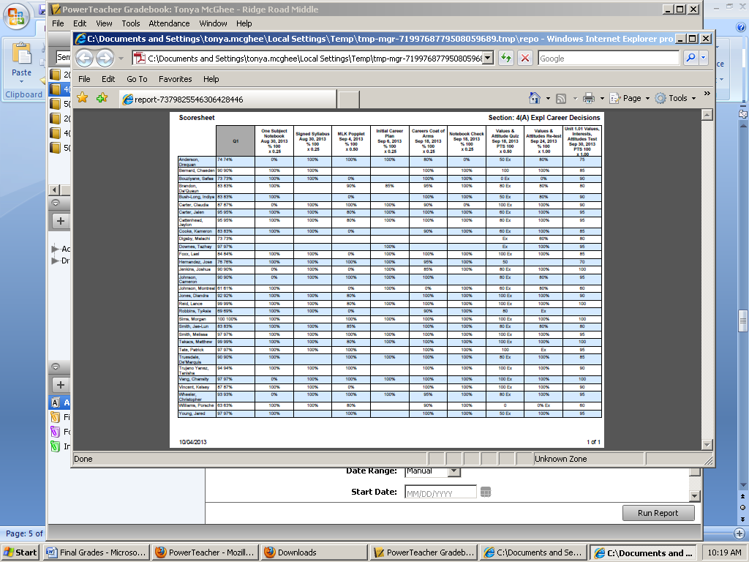

- Finally, click on Scoresheet. The Reporting Term box should be changed from F1 to Q1.

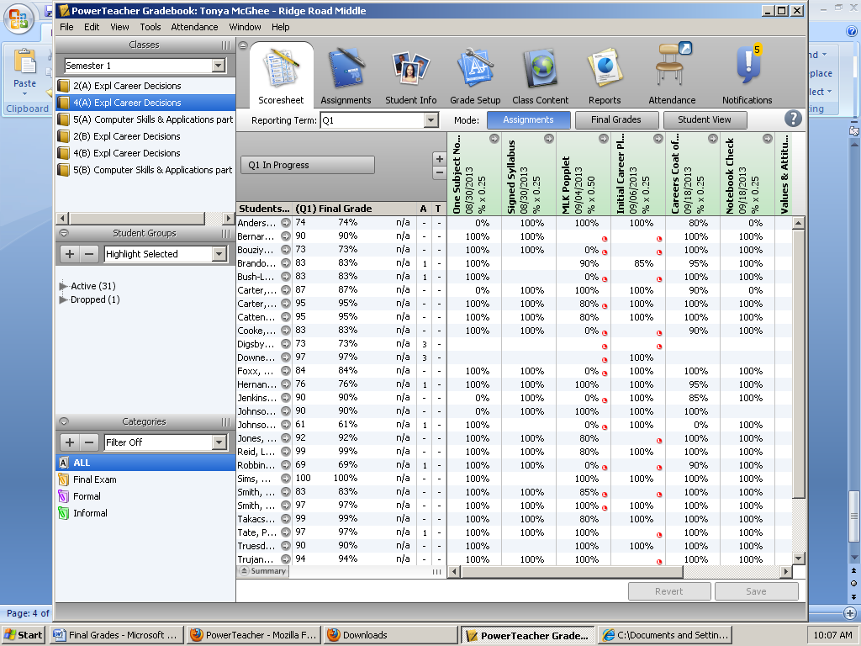

- Click on Q1 in Progress and the check the Final Grade Complete Box. Click OK.

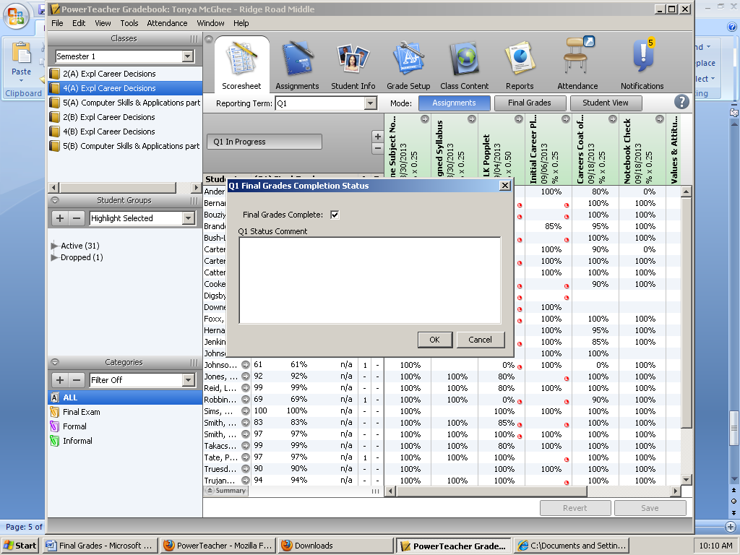

- The Q1 In Progress Box should now state Q1 Grades Complete and it should appear in Green.

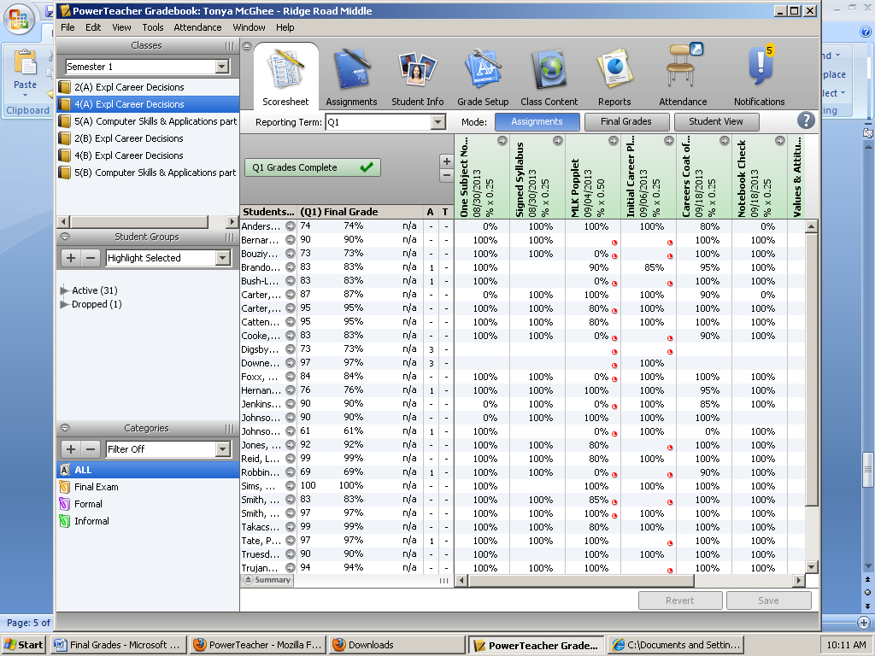
- Congratulations, you’ve finalized grades for one class. Now follow the same steps for your other classes.
Important Notes:
- If you need to add or change a grade after reports have been generated, go back to step #8 and click on Scoresheet. Click on the green Q1 Grades Complete box. Uncheck the Final Grades Complete box and click Ok. Q1 In Progress should now appear in gray. You must now generate your reports again starting with step #1.
- The Data Manager must still provide incoming grades for students new to Ridge.
- There is still a software glitch that will now show an alphabetical grade. Powerschool representatives will inform schools when this glitch has been resolved.

- Students who changed classes WITHIN the school during the quarter:
  - If the original teacher had grades for the student while he/she was in their class, the original teacher must provide the new teacher with the grade. To find the grade
- Click on Dropped
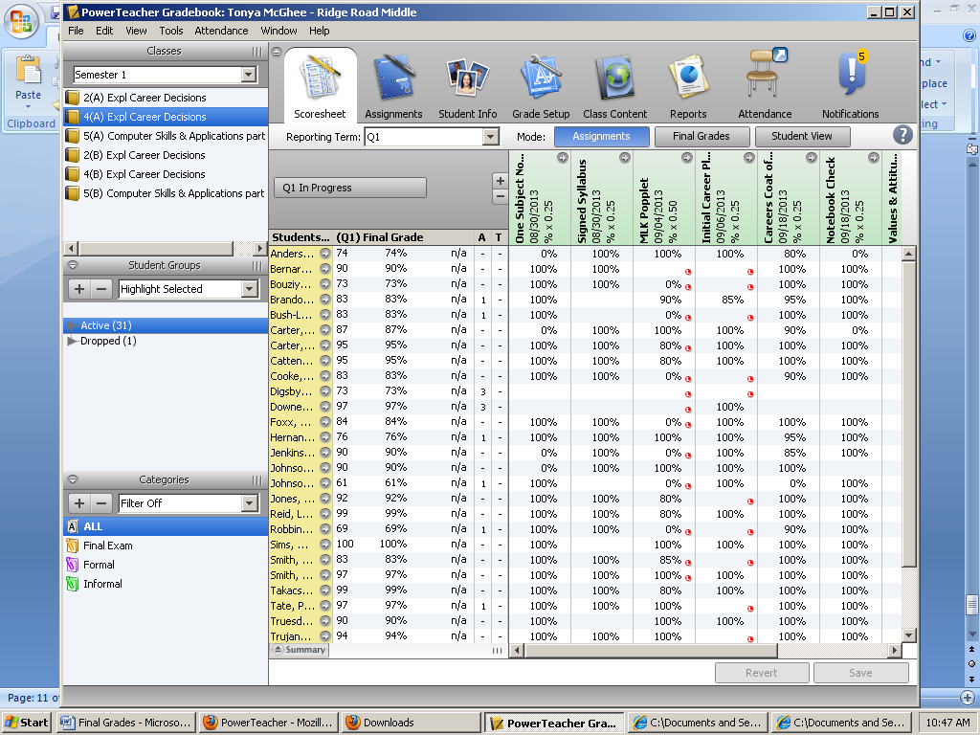

- Change Highlight Selected to Filter Selected. The student’s grade is now available.
